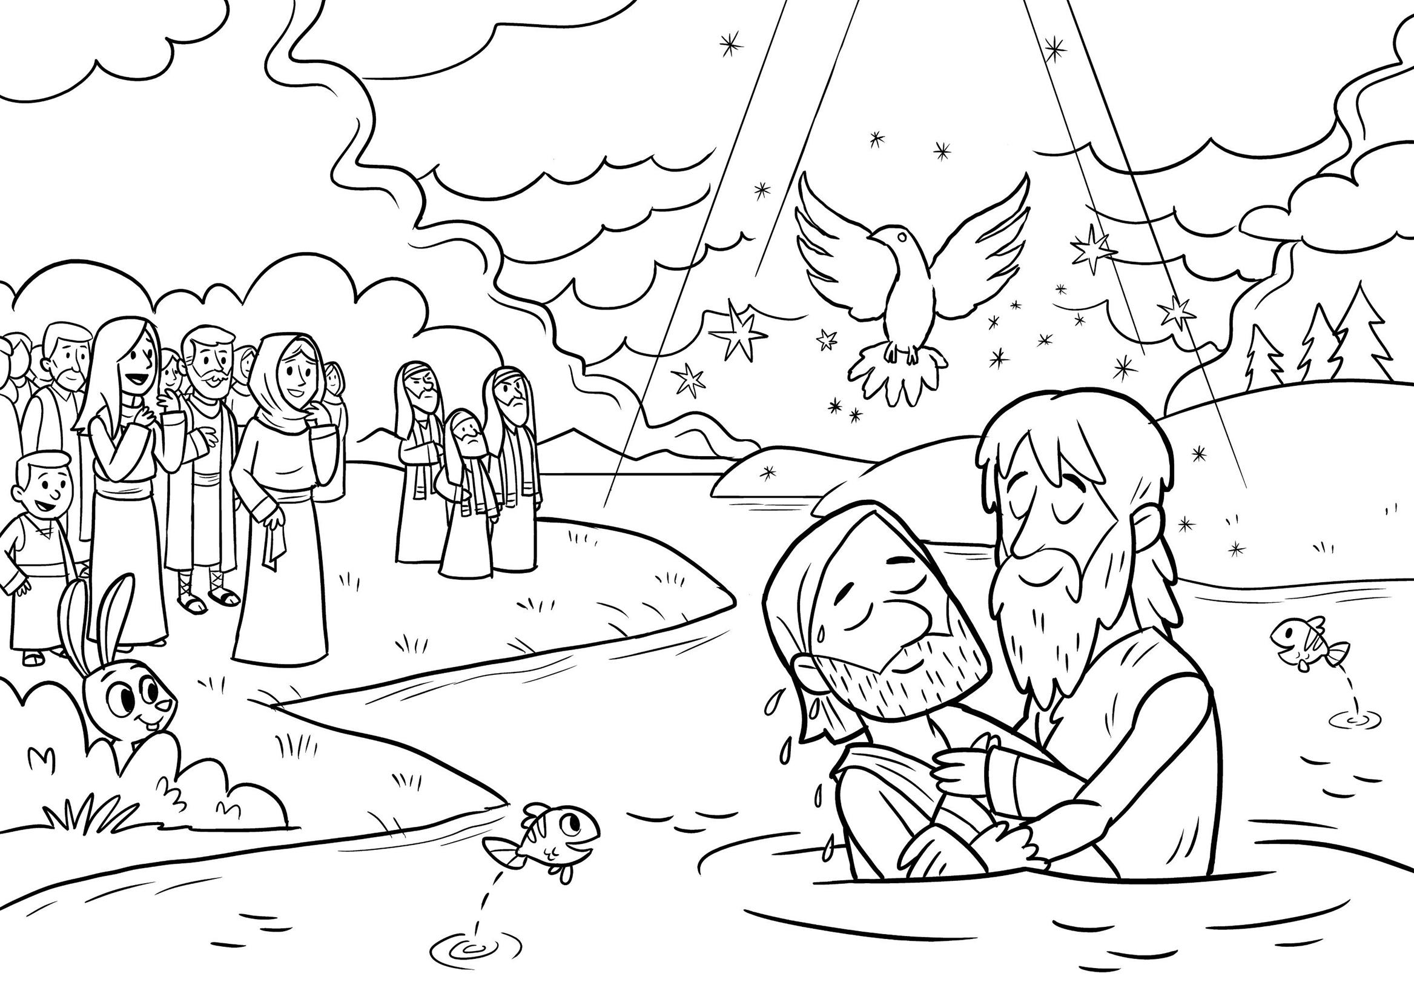
I am not worthy to stoop and loosen the thongs of his sandals.
I have baptized you with water; he will baptize you with the Holy Spirit.
Mark 1:1-8

