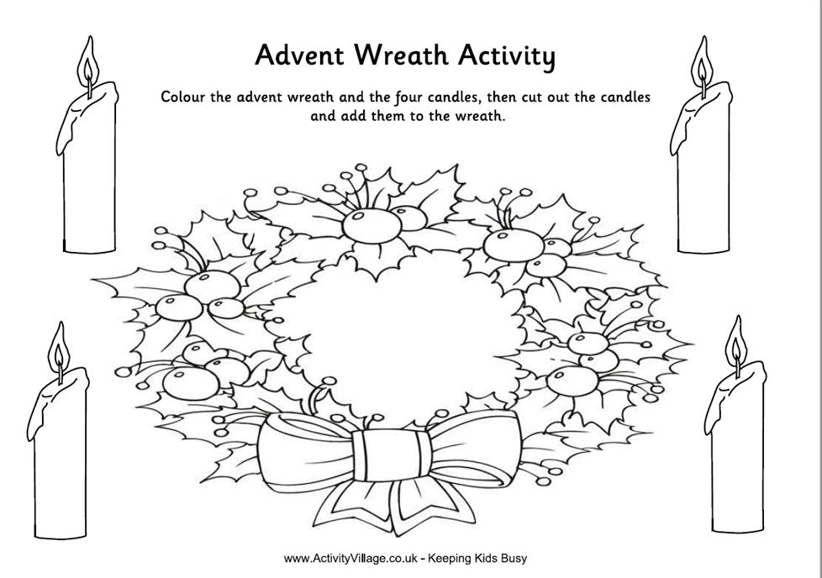

Color the wreath. Color three candles purple. Color one of the flames on one of the purple candles. Color one candle pink. Cut out the wreath and candles. Assemble the wreath. Color a new flame each week of Advent.