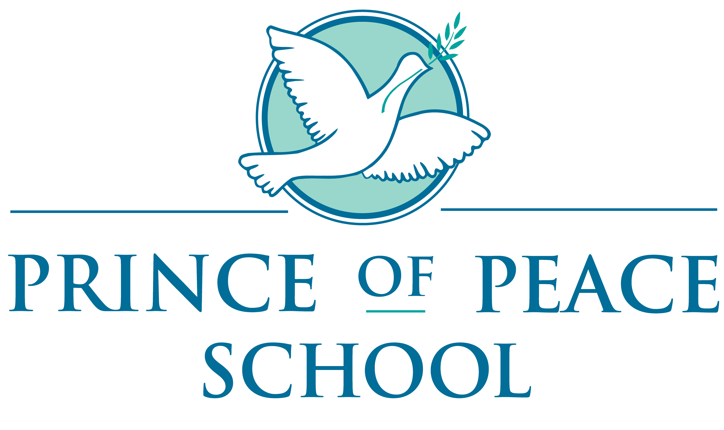

April 29, 2020

Dear Parents,

As we continue to review various aspects of our school operations in response to this pandemic, one area of discussion have been the financial challenges that many of our families, schools and parishes are facing with job and revenue losses. Over the last few weeks, Bishop Foys met with the Consultors, Deans, and some Curia staff to determine the best way to address these challenges.

As a result of these meetings, Bishop Foys has directed that tuition and fees for all elementary and high schools in the Diocese of Covington be frozen for the 2020-2021 school year. This would be in effect at all levels and would also mean that no new fees may be created. This tuition freeze is a way for us to provide some relief to the parents of children enrolled in our Catholic Schools. Financial Aid will be offered this year through a link that will be posted very soon on the school website. All families are encouraged to complete the requirements to be considered. This process is different from the past consideration. The diocese also encourages all families to join one of the ACUE parishes for a tuition discount as well. Active participation in the parish is required. Please visit the Covington Diocese website for ACUE information.

In review, the recommendation that we had anticipated from Governor Beshear to cease in person instruction for the remainder of the 2019-2020 school year was announced last week. Although it was expected, the thought of losing what we have considered so perfunctory for decades-the traditional end of the school year-carries, a sadness and sorrow that is difficult to absorb. However, all things considered, we know this is best for the long term health of all communities. A decision for Prince of Peace Montessori School is the last day for NTI School will be Monday, May 18, 2020. *This will be the last day the children will be required to complete in home assignments. The school building will close on Friday, May 22, 2020.

The teaching staff will be in contact with you to arrange for classroom pick up of supplies, personal belongings, class pictures etc. At this time we also ask for all Library books to be returned, Chrome Books and any outstanding fees to be paid. Report cards will be completed and mailed by the first week of June for your convenience.

All families will be sent a packet of information for the 2020-2021 school year by mid- summer that will include mandatory paperwork for next school year. A Parent Orientation will be conducted in early August before the first day of school. The first day of school is attentively set for Thursday, August 13, 2020. This date could change and if it does, you will be notified as soon as we are informed of changes.

We ask that all families continue to check the school web page for information. It has had many updates over the last several months including school forms and information and it will continue to be updated over the summer months. Dress code information is also posted as well.

If you received any un-paid invoice notices in the mail or by email, please send payments to the school office or drop off in the locked mailbox on the porch. This may include: Extended Day payments, After-School payments, Registration fees for 2020-2021 or tuition payments that were due to the office. We appreciate your support and helping us close out the school year. *If you have not notified the office of your return next year, we will be presuming that you are not returning to Prince of Peace for the 2020-2021 school year.

We continue to express our gratitude to you for your patience and flexibility during these extraordinary times. We would like to ask you to keep our leadership team in your prayers as they work to make decisions that promote the health and well-being of everyone in the Diocese of Covington.

We hope you enjoy the summer months and wish all of you happiness and good health. Please feel free to contact us with any questions or concerns.

Sincerely,

Mr. Tony Barkley
Principal

Ms. Karen Middendorf
Administrative Assistant

