PRINCE OF PEACE SCHOOL
News

No School:
April 18– Holy Thursday
April 19– Good Friday
April 22-26 Spring Break

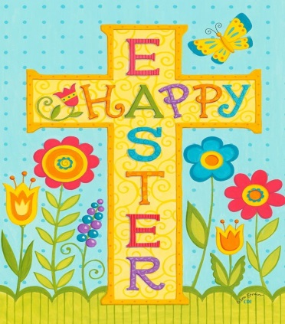

Menu is subject to availability.
Chicken Patty OR
BBQ Sandwich
Waffle Fries
Carrots & Celery with Dip
Pineapple Tidbits
Fresh Fruit
Milk
Cheeseburger OR
Hot Dog
Seasoned Potatoes
Green Beans
Garden Salad
Mandarin Oranges
Fresh Fruit
Milk

Confetti Pancakes
Sausage Links
Smiley Fries
Veggie Boat with Dip
Baked Apples
Fresh Fruit
Milk

Chicken OR
Cheese Quesadilla
Salsa, Sour Cream
Black Beans, Corn
Frozen Sidekick
Fresh Fruit
Milk
Pizza Crunchers OR
Cheesy Flatbread with
Marinara Sauce
Steamed Broccoli
Garden Salad
Diced Peaches
Fresh Fruit
Milk

Chicken Tenders
Dinner Roll
Potato Wedges
Garden Salad
Pineapple Tidbits
Fresh Fruit
Milk
Salisbury Steak OR
Hamburger/Cheeseburger
Mashed Potatoes
Green Beans
Diced Peaches
Fresh Fruit
Milk

Turkey & Cheese Sub
OR Chicken Patty Sandwich
Potato Wedges
Garden Salad
Frozen Sidekick
Fresh Fruit
Milk

Beef Nachos OR
Beef Soft Taco
Salsa, Sour Cream
Refried Beans, Corn
Applesauce
Fresh Fruit
Milk
Cheese Pizza OR
Pizza Crunchers
Steamed Broccoli
Veggie Boat with Dip
Mandarin Oranges
Fresh Fruit
Milk
Queso Chicken over Rice
OR Beef Enchiladas
Salsa, Sour Cream
Shredded Lettuce
Black Beans, Corn
Pineapple Tidbits
Fresh Fruit
Milk
Mini Corn Dogs OR
Chicken Nuggets with Roll
Macaroni and Cheese
Steamed Broccoli
Carrots with Dip
Diced Peaches
Milk
Chicken Drumstick with
Dinner Roll OR
Hot Ham and Cheese Sandwich
Mashed Potatoes
Green Beans
Applesauce
Fresh Fruit
Milk

Holy Thursday-
No School
Good Friday –
No School
NO SCHOOL - SPRING BREAK

Chicken Patty OR
BBQ Sandwich
Waffle Fries
Carrots & Celery with Dip
Pineapple Tidbits
Fresh Fruit
Milk

Cheeseburger OR
Hot Dog
Seasoned Potatoes
Green Beans
Garden Salad
Mandarin Oranges
Fresh Fruit
Milk
Enter Text Here

