Chicken Nuggets w/ Roll OR Hot Ham and Cheese Sandwich
Seasoned Potatoes
Baked Beans
Pineapple Tidbits
Frozen Sidekick
Milk

Mandarin Chicken OR Beef Teriyaki Dippers
Steamed Rice
Steamed Broccoli
Carrots & Celery with Dip
Mandarin Oranges
Fresh Fruit
Milk
Penne Pasta with Meat Sauce OR Chicken Alfredo
Glazed Carrots
Garden Salad
Diced Pears
Frozen Sidekick
Milk
Grilled Cheese OR Fish Taco
Tomato Soup
Green Beans
Oyster Crackers
Diced Peaches
Fresh Fruit
Milk
Chicken Patty or
BBQ Sandwich
Waffle Fries
Carrots & Celery with Dip
Pineapple Tidbits
Fresh Fruit
Milk

Chicken Tenders
Potato Wedges
Garden Salad
Pineapple Tidbits
Fresh Fruit
Milk
Hot Dog or Chili Coney
Sweet Potato Puffs
Veggie Boat with Dip
Applesauce
Fresh Fruit
Milk
Salisbury Steak OR Hamburger/Cheeseburger
Mashed Potatoes
Green Beans
Diced Peaches
Fresh Fruit
Milk
3 or 4 Way Chili Spaghetti
Shredded Cheese
Oyster Crackers
Glazed Carrots
Garden Salad
Frozen Sidekick
Fresh Fruit
Milk

Beef Nachos OR
Beef Soft Tacos
Salsa, Sour Cream
Refried Beans, Corn
Applesauce
Fresh Fruit
Milk
Early Dismissal at 12:00
No Lunch
Cheeseburger or Alfredo Chicken Flatbread
Green Beans
Garden Salad
Mandarin Oranges
Fresh Fruit
Milk

Roasted Turkey
Mashed Potatoes w/ Gravy
Green Beans
Dinner Roll
Apple Sauce
Fresh Fruit
Milk

Mini Confetti Pancakes
Sausage
Veggie Boat with Dip
Smiley Fries
Baked Apples
Fresh Fruit
Milk
Pizza Crunchers OR Cheesy Flatbread with
Marinara Sauce
Steamed Broccoli
Garden Salad
Diced Peaches
Fresh Fruit
Milk
PRINCE OF PEACE MONTESSORI SCHOOL
News

Early dismissal at 12:00
Friday, Dec. 21 –
No Lunch will be served

Christmas break -
Dec. 24 thru Jan. 2

First day of school – Jan. 3

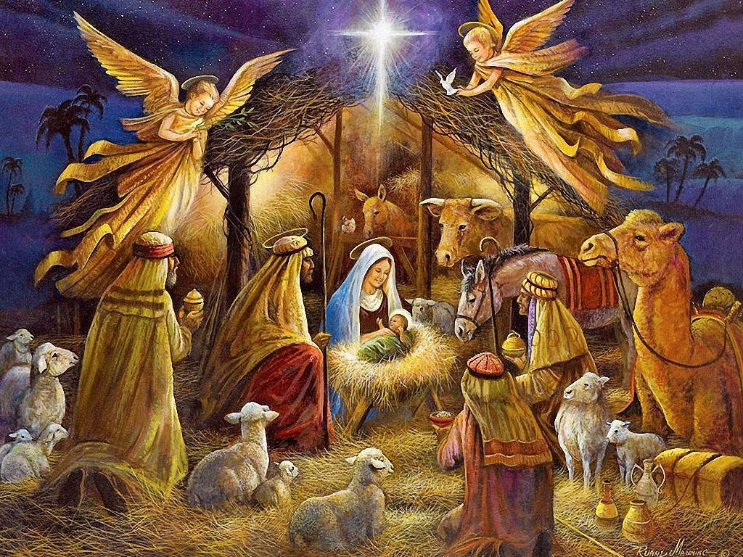

We wish you a Merry Christmas and a very Happy New Year!

